Integrating E-Textiles, Nanotechnology, and AI to Enhance
Physiological Data Acquisition

Emma A Simmons & Sarah C. Simmons
Home School
January 2025

Acknowledgements
We wish to acknowledge the support provided to this project and to us by the following institutions and individuals. Funding support was provided by The Pennsylvania’s Governor’s Office, The Pennsylvania Department of Education, and The Pennsylvania Training and Technical Assistance Network. Mount St. Mary’s University (MSMU) and the MSMU Biology Department permitted the use of the Anatomy Lab and its respiratory equipment. Dr. Dana P. Ward, Professor of Biology at MSMU, and Mary Jackson, Director of the Physician Assistant Program at MSMU provided project supervision and equipment training. Dr. David Moore of Wellspan Health provided medical expertise and Mr. Michael McCabe offered technical expertise in website and mobile application development. A special thanks to our parents, Dr. Lisa S. McLeod-Simmons and Dr. Jeffrey A. Simmons, who served as project supervisors and provided project funding on an as-needed basis.

Abstract
Equitable access to healthcare has been a long-standing problem in the US and globally. Although the US is a leader in medical research, technology, and innovations, one in seven adults regularly experience significant barriers to healthcare, especially those with low income, the elderly, those with disabilities, people who lack independent transportation, and residents in areas with healthcare shortages. Since COVID-19, Telemedicine has become increasingly popular. Being virtual alleviates many of the barriers to healthcare. People can meet with their physicians from home or work, transportation is not a requirement, and the healthcare visit can be with a medical professional anywhere in the country.
However, while the popularization of Telemedicine has increased access for some, it has also resulted in barriers to healthcare. In particular, those with limited access to the internet and those with limited technological literacy often find telemedicine difficult to navigate. In addition, because telemedicine is virtual healthcare, healthcare providers are unable to gather the physiological data easily collected during in-person visits, such as heart rate and respiration rate.
Working with cutting-edge technologies, we designed Vital Air 2.0, which holds the promise of bridging this gap in telemedicine. By integrating advances in materials sciences, nanotechnology, artificial intelligence, electronics engineering, and computer networking we engineered a wearable biofunction sensor prototype with accuracy that is comparable to commercial instruments and can transmit vital signs data in real-time to healthcare providers during telemedicine visits. Vital Air 2.0 is constructed using low-cost materials that are durable and designed for broad accessibility.

Table of Contents
The Problem | ………………………………………… | 6
Figure 1: PA Asthma Rates | ………………………………………… | 7
Background Research | ………………………………………… | 8
Engineering Goals, Constraints | ………………………………………… | 8
Engineering Goals | ………………………………………… | 9
Project Constraints | ………………………………………… | 9
Figure 2: Project Workflow | ………………………………………… | 10
Engineering Design | ………………………………………… | 10
Figure 3: Wiring Schematic | ………………………………………… | 11
Figure 4: Prototype Schematic | ………………………………………… | 11
Prototype Construction | ………………………………………… | 12
Stage 1: Novel Algorithms | ………………………………………… | 12
Stage 2: Biofunction Sensors | ………………………………………… | 12
Stage 3: Power Source | ………………………………………… | 14
Figure 5: Photovoltaic cell | ………………………………………… | 14
Stage 4: Integration into a Wearable | ………………………………………… | 14
Stage 5: IDE and IoT Technologies | ………………………………………… | 15
Stage 6: Building with Universal | ………………………………………… | 15
Testing and iterations | ………………………………………… | 16
Test 1: The Prototype | ………………………………………… | 16
Figure 6: Test Treatment | ………………………………………… | 17
Figure 7: Test Data | ………………………………………… | 17
Test 2: Comparisons | ………………………………………… | 17
Figure 8: Student Researchers | ………………………………………… | 18
Figure 9: Spirometry Test | ………………………………………… | 18
Preliminary Observations | ………………………………………… | 18
Graphene Tests | ………………………………………… | 18
Figure 10: Graphene Coated Fabric | ………………………………………… | 19
Figure 11: Uncoated Fabric | ………………………………………… | 19
Findings and Analysis | ………………………………………… | 19
Sensor Findings | ………………………………………… | 20
Figure 12: Respiration Output | ………………………………………… | 20
Device Comparison Findings | ………………………………………… | 21
Table 1: Biofunction Comparisons | ………………………………………… | 21
Figure 13: Prototype HR | ………………………………………… | 21
Figure 14: Prototype FVC | ………………………………………… | 21
Graphene Findings | ………………………………………… | 22
Figure 15: Graphene Tests | ………………………………………… | 22
Conclusions and Benefits | ………………………………………… | 22
Next Steps | ………………………………………… | 23
References | ………………………………………… | 24
Appendix A | ………………………………………… | 28
Appendix B | ………………………………………… | 29
Appendix C | ………………………………………… | 30
Appendix D | ………………………………………… | 31

Integrating E-Textiles, Nanotechnology, and AI to Enhance Physiological Data Acquisition

The Problem
The use of cutting-edge technology and technological integrations are important means of innovating solutions to complex real-world challenges (Foster, 2023). The global COVID-19 pandemic expediated the use of communications technologies to dramatically accelerate the use of telemedicine, a remote and contactless form of healthcare. In 2019, about 57 million people worldwide saw their healthcare provider using telemedicine. Just five years later, this number more than doubled to over 116 million health consultations in 2024 (Steward, 2024). Studies show that this trend is likely to continue into the future (Pawar, 2025).
However, the integration of telemedicine as a popular medical platform highlights a paradox in this form of healthcare (Caraballo, 2022). While the increased use of telemedicine has broaden access to healthcare for some, such as the elderly, low-income, and disabled, it hinders access for others, those with techno-geographic barriers (those living in rural areas with limited internet access) and those with digital literacy barriers (Haimi, 2023). But there is a more pressing barrier to healthcare that arises from the popularity of Telemedicine. Virtual health can hinder equitable access for many of the patients that it seemingly helps. The core of the problem lies in the contactless nature of virtual medical consultations. In short, healthcare providers are not able to directly measure key vital signs for patients via Telemedicine platforms, including heart rate, respiration rate, blood oxygen saturation level, and forced vital capacity. These are important biofunctions for many chronic diseases. This means that medical professionals do not have the critical information that they would otherwise have during traditional in-clinic healthcare visits. Nearly half of physicians have indicated a concern regarding the reliability of telemedicine because of its contactless nature (Habib, 2023). For chronically ill patients, such as those with Chronic Respiratory Diseases (includes COPD, asthma, and COVID-19), this often means that they must use in-person healthcare. And access to in-person medical visits for the elderly and disabled is challenging due to cost, personal mobility difficulties, and a lack of transportation (Figure 1). This is exacerbated by physician shortages throughout the US that are expected to continue for the next decade (AMA, 2024).

Figure 1
PA Asthma Rates and Transportation Barriers to Healthcare
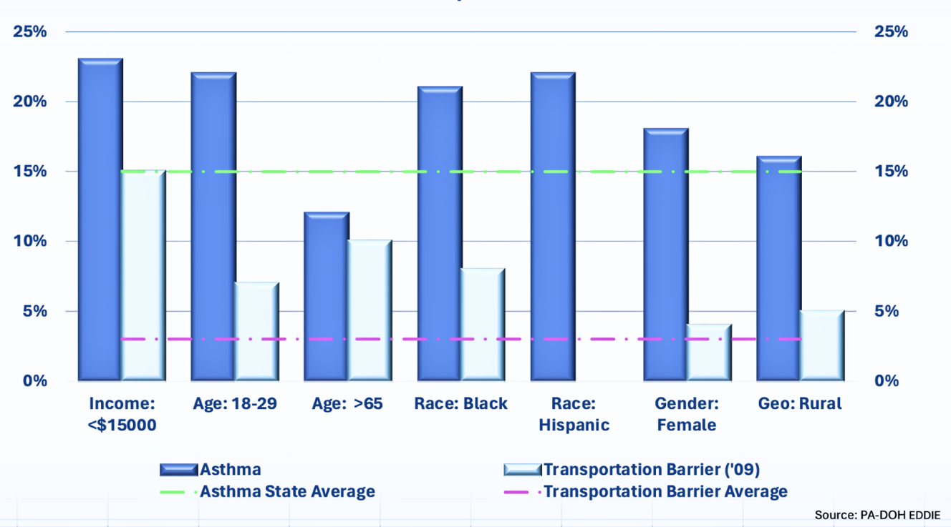
This chart illustrates the connections between chronic diseases, demographic variables, and access to healthcare. In Pennsylvania, the youngest and oldest citizens, those with low incomes, racial minorities, and women are more likely to have asthma and are more likely to experience transportation barriers to accessing healthcare. (Source: PA-DOH EDDIE, 2022)
The key goal of this project is to advance equitable access to healthcare by designing and constructing a working low-cost, easily accessible, and wearable prototype that utilizes noninvasive and secure methods of collecting physiological data that can be stored for future use or transmitted in real-time to the user’s choice of recipients. This can allow medical professionals to collect the physiological data needed from a patient during a telemedicine visit. An added goal of this project is to develop this system using materials and technologies that are frequently used in the more expensive and complex biosensing systems.
It should be noted that this prototype is not developed as a medical or diagnostic tool and should not be used in this manner. It is a prototype that is intended to be used to test the feasibility of such a device.

Background Research
Recent technological advances have made wearable devices a possible solution to the shortcoming of Telemedicine (Kang, 2022). A medical wearable device is an independent and noninvasive apparatus worn directly on the human body or on clothing that performs basic physiological functions, respiration rate, heart rate, forced vital capacity, and oxygen saturation of the blood (Hemapriya, 2017).
While these devices have the potential to greatly improve patient outcomes by giving healthcare providers valuable information that they otherwise may be able to acquire during a virtual telemedicine consultation (Hswan, 2021), many common wearable devices, e.g. smart -watches, are costly and not covered by health insurance. Moreover, some studies show that the data derived from these devices are insufficiently accurate for medical use (Hahnen, 2020).
Medical-grade wearable devices used by patients in a home setting are more accurate but have notable limitations. First, many medical grade wearable devices are expensive, some require subscriptions for monitoring or connectivity, and not all are covered by insurance (Wetman, 2022). Second, because adhesives are typically used to attach the device to the patient's skin, the skin can become irritated, making it difficult to use or wear for prolonged periods of time (Thyssen, 2010). Third, younger patients or those with disabilities may interfere with the device thereby disabling it (Wei, 2019). A fourth problem is the ability of doctors to access the data recorded by the units since some devices record but do not transmit the data to healthcare providers in real-time (Mortimer, 2022).

Engineering Goals, Constraints, and Constraint Mitigation Efforts
The project began by seeking Institutional Research Board (IRB) approval from the research institution where we could conduct testing, Mount St. Mary’s University. IRB approval was granted with no revisions to the plan (Appendix A).
Engineering Goals
- Utilize advancements in materials science, sensor technology, electronics engineering, and sustainable energy technology to develop a Biomedical Engineering Prototype.
- Develop a unique system of biosensors operated by novel algorithms that accurately measures key vital signs typically obtained during in-person telemedicine visits.
- Heart Rate (HR) - the number of times the heart beats per minute.
- Respiration Rate (RR) - the number of breaths a person takes per minute.
- Forced Vital Capacity (FVC) - a measure of the maximum volume of air a person can forcefully exhale after taking a deep breath.
- Blood Oxygen Saturation Percentage (Sp02) - the percentage of oxygen in a person's blood.
- Design and construct a system of biosensors that adhere to Universal Design Principles.
- Integrate Artificial Intelligence (AI) to enhance the system’s customizations.
- Create a mobile application that accurately displays and securely transmits physiological functions using Wi-Fi and IoMT networking.
Project Constraints
This is a complex engineering project that seeks to integrate advanced science and engineering techniques, technologies, and materials to develop a working prototype. However, this project has several constraints that may impact the project goals.
- Budget limitations. While a key goal is a low-cost prototype, some materials may be outside the limited project budget. To address this constraint, the project conservatively uses key materials. In addition, student researchers or their adult project supervisors (teachers) were able to obtain discounted subscription pricing from Blynk, the internet hosting platform service provider used for the mobile application (Appendix B).
- Time constraints. This project must be completed within a five-month timeframe. While this is a very restrictive timeframe for a project of this scale, efforts will be made to optimize work time through a careful division of labor based on interest and skill specialization. Because the testing phase of the project will be carried out at a university laboratory, pacing of the project may be adversely impacted by the availability of the lab and the university faculty members who will assist with the testing. A workflow time chart will also be created to improve project pacing (Figure 2).

Figure 2
Project Workflow Timetable
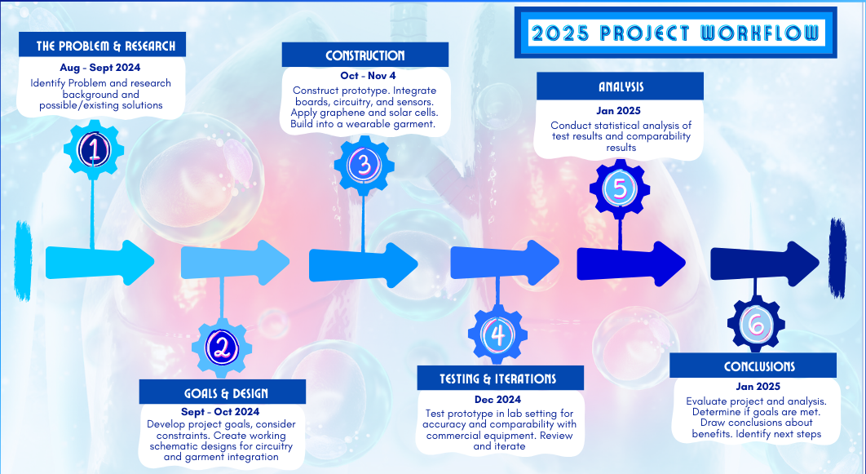

- Safety considerations. Because the project involves activities that carry some risks, such as soldering and handling materials that are new to the student researchers, preventing harm and minimizing risks to those involved in the project and project equipment and materials is an important focus. To clearly identify these safety considerations, a risk and risk mitigation plan is included in this project (Appendix C).

Engineering Design
Over the past few years, there have been numerous developments in diverse fields of science and technology. Artificial intelligence, nanotechnology, sensor science, bioengineering, and Internet of Things, have rapidly made their way into mainstream science and engineering.
This project develops a novel way to obtain biofunction data by integrating technological and scientific advancements in a way that is low cost, uses readily obtainable component materials, is accessible for diverse populations, can be comfortably worn for extended periods of time, and can store and stream biofunction data securely and in real-time.
Figure 3  Wiring Schematic | Figure 4  Prototype Schematic
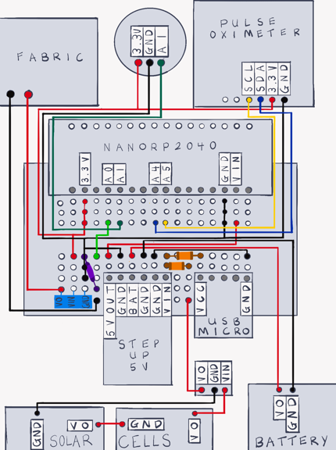 | 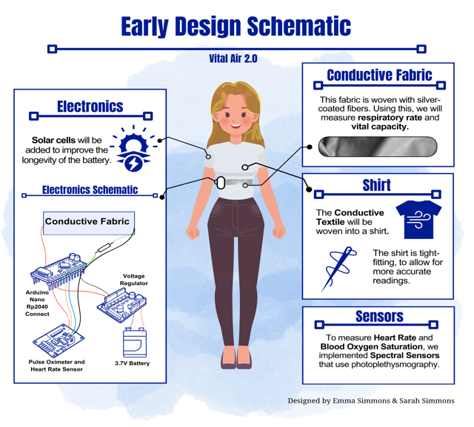
The prototype, named Vital Air 2.0, consists of several key components. Programmed with novel algorithms, a small microprocessor is used to control a system of sensors through a series of circuits, as shown in Figure 3. The sensors include spectral types along with a unique conductive fabric that is engineered to act as a biofunction sensor. Artificial Intelligence is incorporated via an inertia movement sensor to distinguish between typical and atypical function readings. A lithium battery and solar cells provide power to Vital Air 2.0.

During this design phase, two key schematics were designed to serve as blueprints for the prototype’s circuitry and the overall design of the devices system of physiological sensors. The schematics also provided clarification of the materials needed for the prototype, as well as a building guide for component location and integration (Figure 4).
During the design phase, a list of needed materials and equipment was also assembled to help ensure they were on hand when needed. This helped to ensure the project workflow continued with minimal interruptions (Appendix D).
The project was designed to adhere to Universal Design Principles to enhance accessibility for a broad range of users to help augment equitable access to healthcare.

Prototype Construction
This phase of the project involves the actual construction of the prototype. It is important to note that this is a prototype, not a fully functioning, market-ready medical device. However, if it functions as designed, as indicated in the testing phase, it will demonstrate how the integration of advanced technologies can be used to accurately and reliably collect and analyze physiological functions data in a way that is portable, low cost, and widely accessible to diverse populations. The construction took place in several stages.
Stage 1. Novel Algorithms for the Microcontroller
This stage consisted of extensive coding to program the Arduino Nano microcontroller. The processor has several integrated capacities, including Wi-Fi 802.11b/g/n and Bluetooth / BLE v4.2 connectivity, a 16mb flash memory, and an inertial measurement unit, as well as advanced IoT and AI capacities. A critical step in constructing the prototype is writing novel algorithms that instruct prototype’s sensors how and when to measure specific biofunctions of the wearer and how to convert the analog physiological function data it receives from the sensors into readable and visualizable data. Throughout the construction process and in the post-testing iterations, these algorithms were modified to achieve increased sensor measurement accuracy.
Stage 2. Biofunction Sensors
The next stage consisted of constructing the physiological function sensors. These include a smart fabric sensor and two spectral sensors.
- Conductive Fabric Sensor. The key and most novel sensor was developed from electrically conductive textiles, which is a fusion of commonly used fabric materials and advanced materials science technology. These fabrics are made with metallic fibers that are electrically conductive, such as silver or copper, or with fibers that are coated with conductive materials. Conductive textiles are strong, durable, flexible, and heat resistant (Kiron, 2024). This sensor was added into the prototype to measure respiration rate and forced lung capacity. The conductive fabric had to be precisely located in an optimal position on the wearable garment for it to produce the most accurate RR and FVC biofunction readings. RR is measured using inhalations and exhalations while FVC is captured by measuring chest expansion. A unique algorithm was coded into the microcontroller and sent to the conductive fabric, programming it to act as a biofunction sensor, capture these voltage changes, and convert them to a respiration rate measurement. The conductive fabric is sewn into the inside of the shirt and is connected to the microcontroller with 28mm AWG single-core insulated wires. Because the fabric will be exposed to moisture, we coated a test sample of conductive fabric with Graphene epoxy to evaluate how well this nanomaterial protects or enhances the fabric’s durability.
- Spectral Sensors. Unlike the smart fabric sensor, spectral sensors measure vital signs’ functions using reflected light waves. We incorporated a biometric sensor that measures both HR and SpO2. The senor uses a light emitting diode that reflects off arteries just under the skin of the wearer’s finger. It senses the level of light absorption using photoplethysmography. An algorithm then translates this data into HR and SpO2 data. The processor was wired and soldered to each spectral sensor to measure HR and SpO2 using Photoplethysmography technology. Photoplethysmography uses low-intensity infrared (IR) light to measure changes in blood volume, which is used to measure FVC.
- Measurement Sensor with AI. A 6-axis Inertia Measurement Unit sensor (IMU) is coded to measure angular velocity and linear accelerations. This allows the prototype to determine the movement of the wearer, e.g. no movement, slow movement, fast movement. The IMU is also constructed to be Artificial intelligence compliant. This enabled us to code it to identify complex movements and, using AI, to ‘learn’ user movements. This will allow Vital Air 2.0 to distinguish between typical and atypical respiration (RR) patterns in the wearer.
Stage 3. Power Sources
The prototype has two power sources. A traditional power source is a lithium polymer rechargeable battery pack with 3.7V and a 2000mAh capacity. To enhance sustainability, two mini, flexible, waterproof panels of photovoltaic cells measuring 95mm x 58mm x 1mm with a weight of 20 grams were attached to the sides of the shirt that houses the Vital Air 2.0 prototype (Figure 5). The goal of integrating this advanced energy technology into the prototype is to improve the longevity of the device's power source, thereby enhancing its sustainability.
Figure 5
Photovoltaic cell used a sustainable power source for the prototype
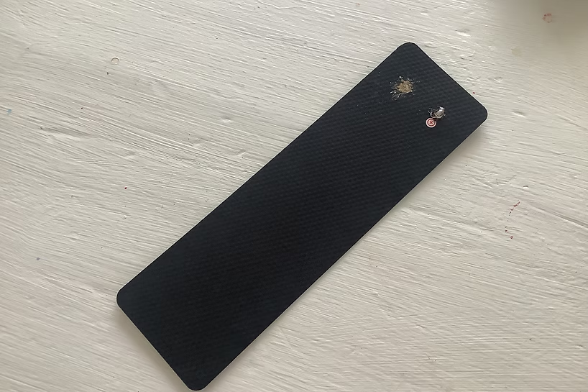

Stage 4. Integration into a Wearable Garment
` Once assembled, the system of biofunction sensors is integrated into a wearable garment, a nylon athletic-grade shirt with a tight weave that retains its elasticity through repeated uses. The electronics are housed in a small pocket on the lower side of the shirt. They can be detached from the garment to allow the garment to be washed and dried. The conductive fabric does not detach but can be washed and dried along with the shirt. The use of the shirt helps to achieve the project’s goal of comfort and portability.
Stage 5. IDE and IoMT Technology for Data Management, Display, and Transmission
To maximize productivity and efficiency, an integrated development environment (IDE) is used to design, create and modify C++’s scalable code, debug, and deploy a mobile software program for data storage and visualization. Vital Air 2.0’s mobile presence is hosted by a Blynk IoMT platform, allowing the physiological function data to be transmitted in real-time to anyone the user selects. Security is also important when relying on medical data. The Blynk host uses industry standard TLS (transport layer security) protocols when transmitting data, known as TLS. Transmissions are encrypted using frequently renewed Let’s Encrypt certificates. Access to Blynk platform is through the secure HTTPS API.
Stage 6. Building with Universal Design Principles
The Vital Air 2.0 prototype is built using Universal Design Principles to broaden equitable access to healthcare for a wide range of users. Building the prototype using these principles also advances the project’s core engineering goals.
- Equitable and Flexible Use. Constructed with low-cost and sustainable materials. Accessible to users with diverse abilities and needs, such as options for those with either right- or left-hand dominance and customizable settings to accommodate users with different physical and visual needs
- Simple and Intuitive. The device is designed to be easy to use and maintain by users from diverse backgrounds and physical capabilities. For example, the prototype is held in place using a system of simple snaps that so that the electronics can be easily removed for washing and then reinstalled. The mobile application has clear instructions for users with diverse educational backgrounds.
- Communications options. The prototype includes features that allow users to customize communications settings, including a mobile application that can be integrated with commercial voice control assistants, such as Alexa or Google. The prototype’s mobile app has settings for different sound tones and visual flashes to notify users of alerts.
- Tolerance for Error. The device is designed to minimize negative consequences of unintended or accidental use. For example, the mobile application’s control buttons/slides can be pressed or moved repeatedly without freezing.
- Low Effort. The Prototype can turn on or off with the press of a button, and the mobile app has multiple options for buttons or sliders.
- Clarity. The mobile application has large controls that are easy to read. The text is scalable, and colors are customizable.

Testing and Iterations
The Prototype’s sensor system was tested to determine accuracy and ease of use. Testing took place at Mount St. Mary's University Anatomy Lab using a BioPac Spirometer / ECG Prototype HR and SpO2 were compared to a Santamedical oximeter. All tests on the prototype and sensors or tests using commercial equipment were conducted under the supervision of a Project Supervisor (teacher) or a faculty member at Mount St. Mary's University.

Treatments
During the testing, three specific treatments were used to test the functionality and accuracy of the prototype. These consisted of one student researcher engaging in three low to moderate intensity physical activities: sitting, standing, and climbing stairs.
Test 1. The Prototype
In this test, a student researcher wore the Vital Air 2.0 prototype while engaged in the three treatment activities. During the testing, another team member observed the test subject and the prototype, noting if there were any observable problems with the prototype’s functionality or ease of wearability (Figures 6 and 7). This team member also observed the real-time vital signs measurements, including HR, RR, SpO2, and FVC as they were streamed to the Prototype’s mobile application, which was accessed using an Apple iPhone.
Figure 6  Test treatment: Stairs | Figure 7  Test data: Student recording data
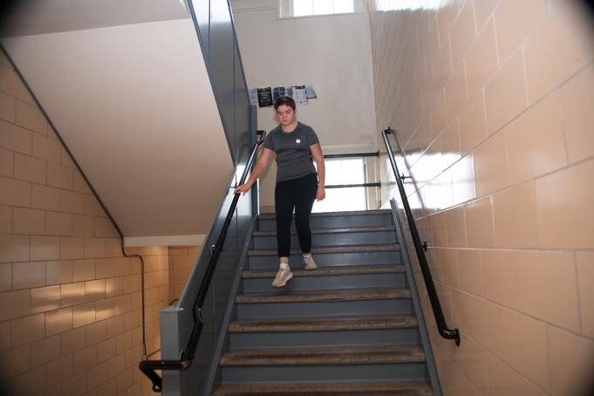 | 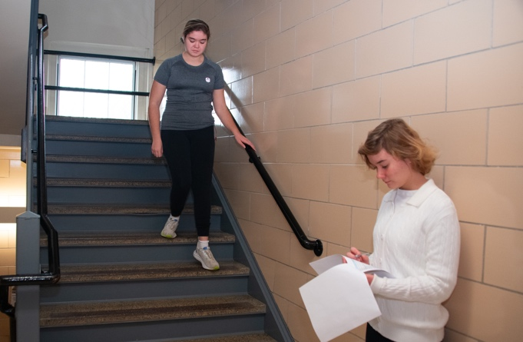

Test 2. Comparisons
A second series of testing was conducted to gather data to compare the Prototype’s accuracy with Commercial equipment used to measure physiological functions. Immediately following each treatment, the vital signs of the student researcher wearing the Prototype were measured by the commercial equipment, including a BioPac(TM) Spirometer and ECG instrument, which measured Forced Vital Capacity and Heart Rate (Figures 8 & 9).
A Santamedical pulse oximeter was used to measure the student researcher’s blood oxygen saturation level. The pulse rate was measured manually by the attending physician assistant, who observed and recorded the count. Manual respiration counts are a common method of measuring Respiration Rate in clinical settings (Johns Hopkins, 2022).

Figure 8  Student Researchers calibrating Spirometer | Figure 9  Spirometry Test
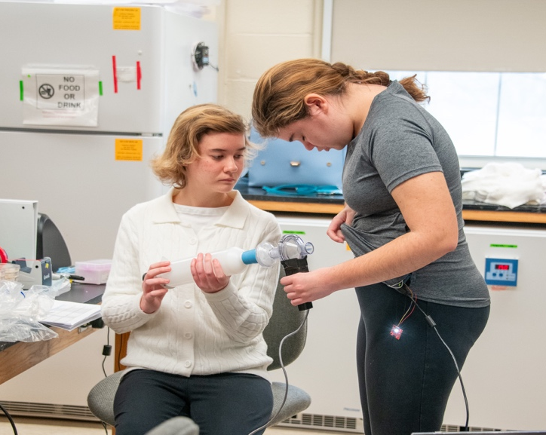 | 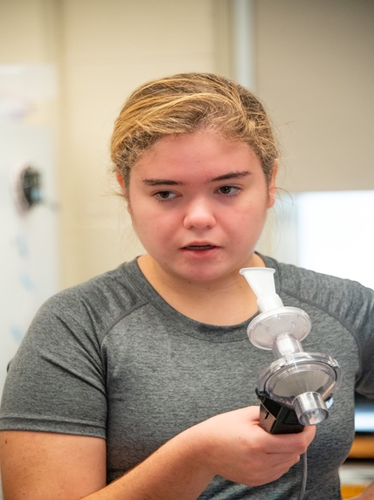

Preliminary Observations and Iterations
The initial testing process showed that the Prototype’s FVC and RR measurement outputs were not as accurate as we wanted. To optimize these functions, we revised the equation used to calculate the FVC measurement and we adjusted the C++ code used to measure RR (Appendix D). Both of these are algorithms we wrote for this Prototype.

Original Equation for FVC: 64.935 x volt Difference + 4.6429
Updated Equation for FVC: 27.871 x volt Difference + 1.7794

We also decided to make adjustments to the HR. This change involved increasing the sampling rate and changing the sensor’s location from the torso to the wrist (Appendix E)
Graphene Tests
A graphene epoxy was applied to the conductive fabric to determine if it would improve the durability of the fabric and protect the textile’s conductivity, especially with washing. (Rohen, 2024). The conductive fabric coated in graphene and a control fabric (uncoated conductive fabric) were washed 20 times by hand using a commercial laundry detergent (Gain Original, HE). The fabrics were layout on a clean, flat surface to air dry for approximately 2 hours. After each washing and drying cycle, the strength of the coated test fabric and the control fabric was evaluated using a standard push-pull test (Kuphalt, 2023). A digital force gauge tensile strength meter was used to carryout the test.
The test and control fabrics were visually observed after each washing and drying cycle. The textiles were evaluated for pilling and tearing, both major and micro tears using an Andonstar AD249S-M Plus digital microscope with 2040x magnification displayed on a10.1' high resolution screen. Observations were recorded in a logbook and with digital photographs (Figure 10 & 11).

Figure 10 | Figure 11
Graphene Coated conductive fabric at 2000x magnification | Conductive Fabric, uncoated, at 2000x magnification
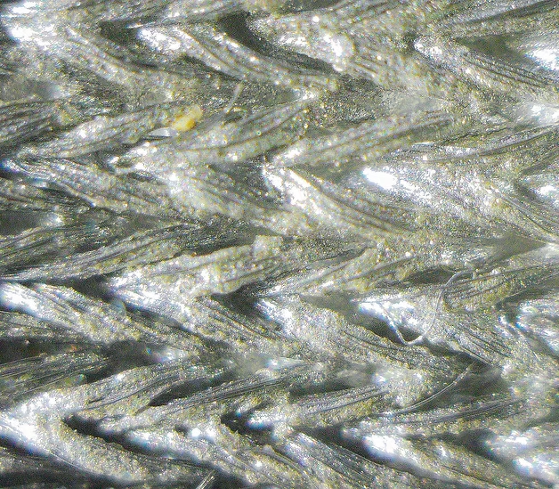 | 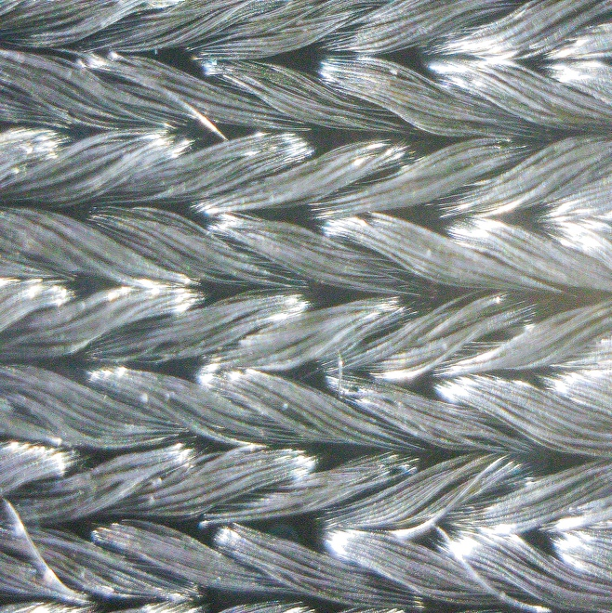

Findings and Analysis
The Prototype tests and the Comparison tests show that the Vital Air 2.0 prototype met the project’s engineering goals. A functioning biomedical prototype that successfully acquired and measured key biofunctions (HR, RR, FVC, and SpO2), and was designed and constructed using advanced materials, technologies, and techniques. Further, this biofunction sensor system is able to transmit vital signs data in real-time using Wi-Fi through an IoMT network. Moreover, the device was engineered using Universal Design Principles. The configuration of the prototype and mobile app is simple and intuitive. While the device is durable, user interactions require minimal effort and can be easily aided by commercial voice assistants found on smart devices that house the mobile application. Finally, Vital Air 2.0 is designed for equitable and flexible use by wearers with diverse abilities, needs, and backgrounds.
Sensor Findings
The test results on the functionality of sensors confirmed that they performed as designed, that is, they measured the physiological function they were intended to measure. This is especially noteworthy for the RR and FVC sensors since these sensors were uniquely designed using electrically conductive fabric and coded with novel algorithms. Figure 12 shows the prototype’s respiration output, where a trough in the signal represents an inhalation, and a peak represents an exhalation.

Figure 12
Respiration Rate Output from Prototype
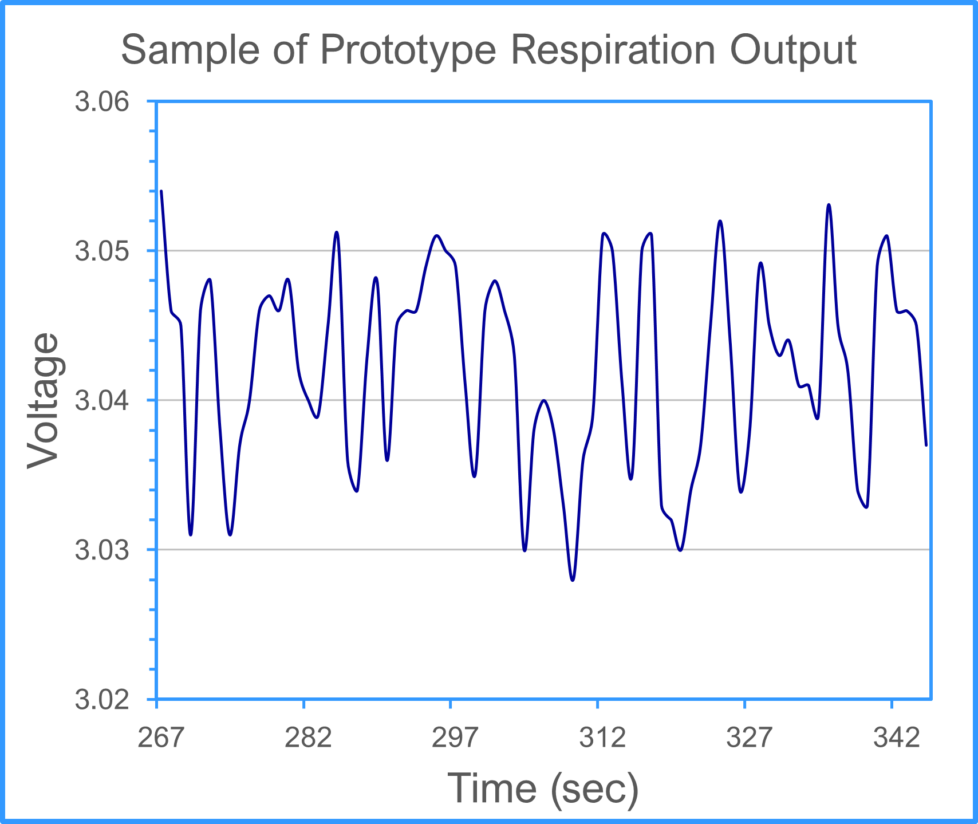

Similarly, the HR and SpO2 sensor measured HR and SpO2 as expected.
Device Comparison Findings
Pearson-r analysis indicated that Vital Air 2.0 produced vital biofunction measurements comparable to commercial equipment, with p-values ranging from <0.01 to 0.1 (Table 1).

Table 1
Biofunction Comparisons by Instrument Type
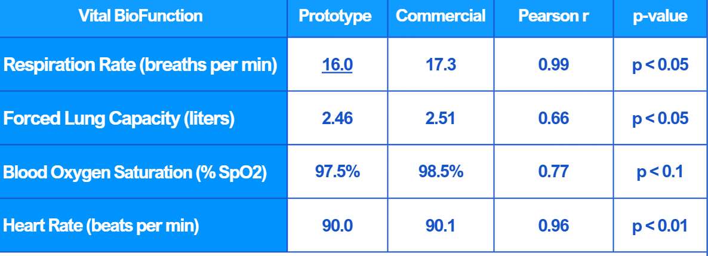

Figures 13 and 14 show how highly correlated the Vital Air 2.0’s HR and FVC readings were to the commercial devices.
Figure 13 | Figure 14
Prototype HR Comparable to Commercial | Prototype FVC Comparable to Commercial
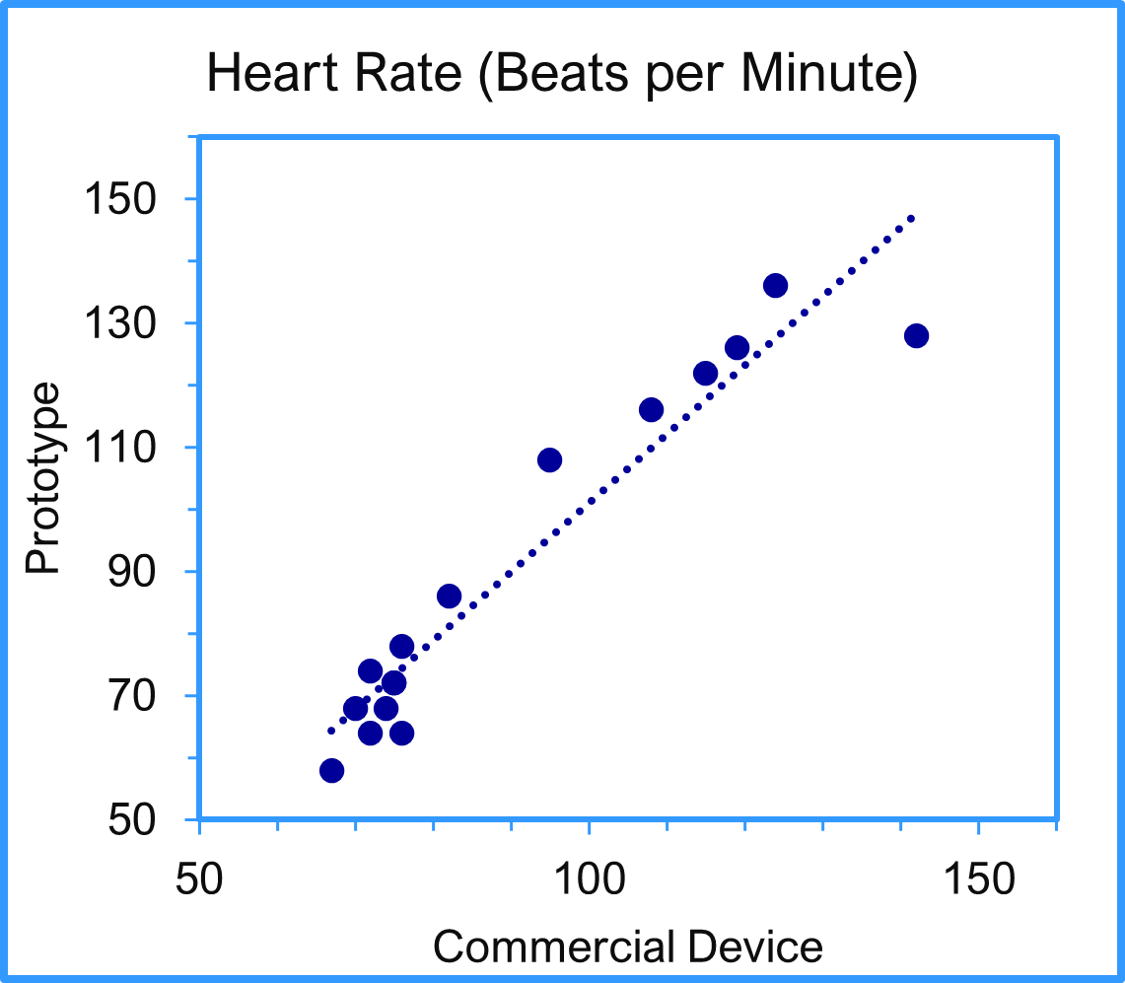 | 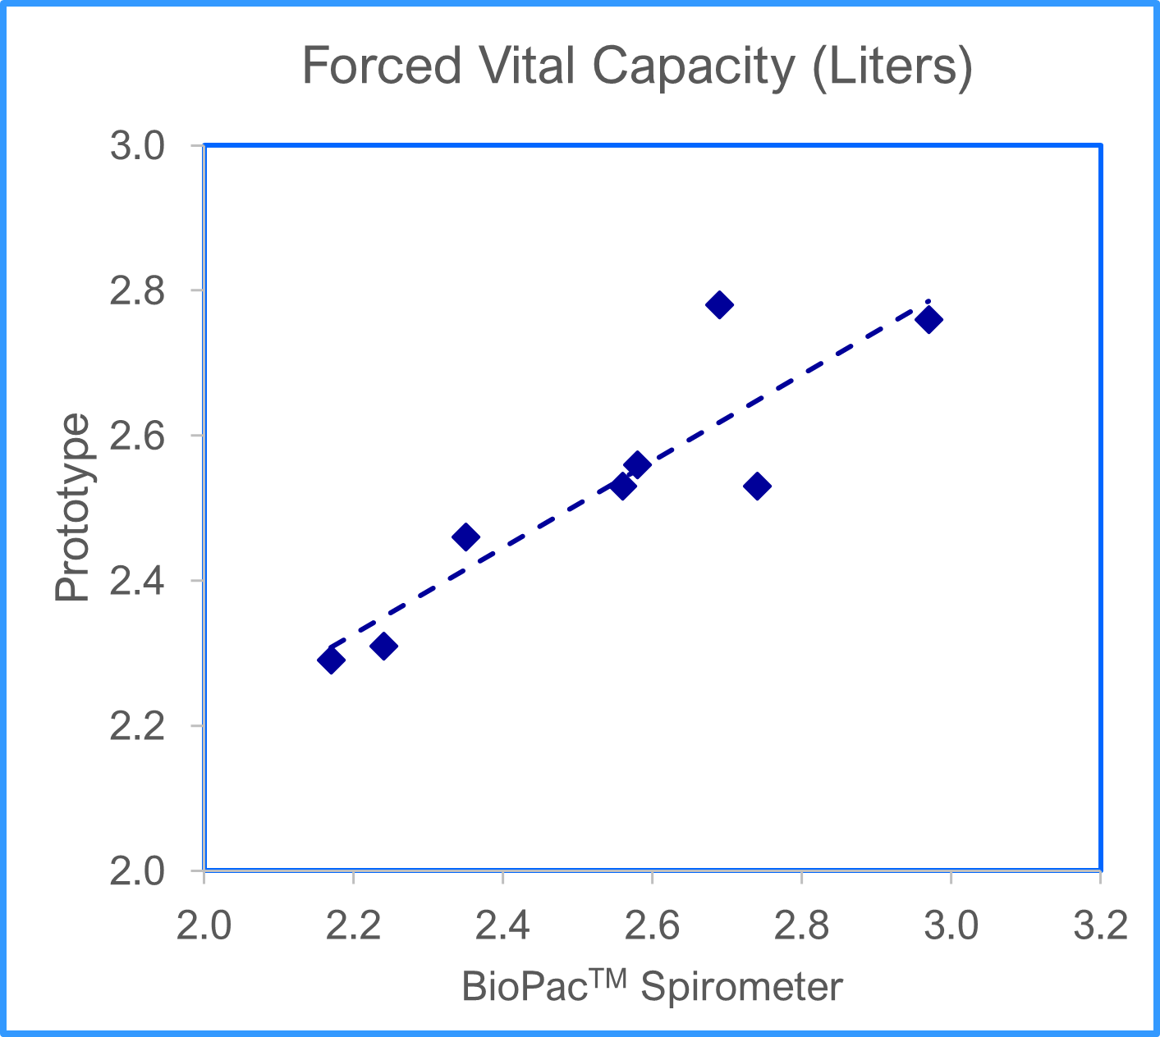

Graphene Findings
The graphene-coated textile saw an increase in resistance compared to the control conductive textile. This is likely because the electricity flows through the graphene instead of the conductive fabric, which has a higher resistance, as seen in Figure 15. The graphene-coated textile also had a significantly higher tensile strength than the control. Because a lower tensile strength and resistance are more ideal for our Prototype, we concluded the graphene would not improve the Prototype.
Figure 15
Graphene Findings: Graphene has limited impact on conductive fabric
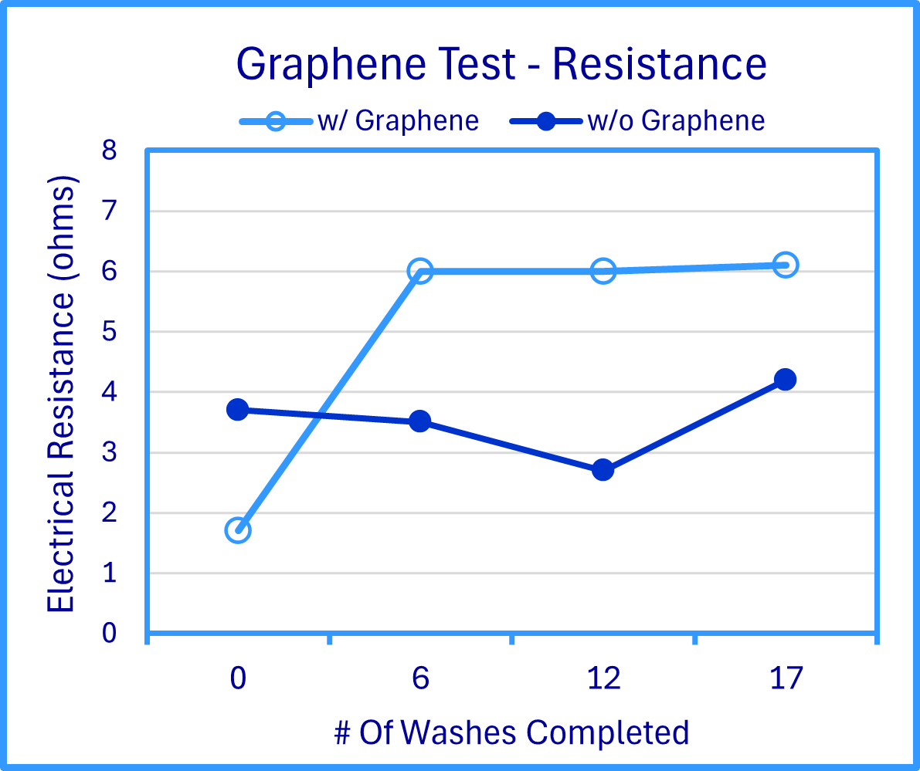

Conclusions and Benefits
Our Prototype accurately measures respiration data and patterns, forced vital capacity, heart rate, and blood oxygen saturation. It determines the movement status of the user, calculates breaths per minute, differentiates typical and atypical respiration patterns, and displays data on a mobile and computer application through IoMT connectivity. The Prototype adheres to all our project goals. It increases accessibility to healthcare by improving the feasibility of telemedicine, using cost-effective materials, and meeting many of the Universal Design Principles. After analyzing the data, we can also conclude that Vital Air 2.0 offers a comparably accurate and lower-cost alternative to commercial testing equipment that requires clinic visits.
Vital Air 2.0 allows users to be actively responsible for their own healthcare by self-monitoring their pulmonary function. It provides healthcare personnel with real-time and longitudinal pulmonary function data even when they are unable to meet patients in person. In turn, this information enables clinicians to diagnose and treat people with significant respiratory diseases more effectively and efficiently.
Next Steps
There are several design modifications that can be implemented to improve the functioning of Vital Air 2.0. Wires connecting the microprocessor to the sensors can possibly be replaced with conductive fabric. Using a very low resistance fabric could be a more flexible and discreet alternative. One issue that caused some problems during this project was short circuits in the boards, likely due to poor wiring connections. Using a custom printed circuit board will help stabilize these connections. Another possible modification that might enhance the prototype’s functionality is engineering a conductive textile replacement for ECG electrodes.

References
American Association of Medical Colleges. (2024). The Complexities of Physician Supply and Demand: Projections From 2021 to 2036 (Global Data Plc, Ed.). AAMC. https://www.aamc.org/media/75236/download?attachment.
Cardiology Shop. (n.d.). Vital signs monitors. https://www.cardiologyshop.com/patmon.html.
Caraballo C, Ndumele CD, Roy B, et al. (2022, October 28). Trends in Racial and Ethnic Disparities in Barriers to Timely Medical Care Among Adults in the US, 1999 to 2018. JAMA Health Forum. 3(10):e223856. doi:10.1001/jamahealthforum.2022.3856.
Center for Disease Control. (2025, January). Quarterly provisional mortality estimates. National Center for Health Statistics. https://www.cdc.gov/nchs/nvss/vsrr/mortality-dashboard.htm#.
De La Fuente, J. (n.d.). Graphene - What is it? Graphenea. https://www.graphenea.com/ pages/graphene?srsltid=AfmBOoo45azZ55Hw64du2qI-42TJBL58h6-5UfjAN6sA8jLG4t139iah.
DiMaria-Ghalili, R., Foreshaw Rouse, A., Coates, M., Hathaway, Z., Hirsch, J., Wetzel, S., Park, Y., Johnston Walsh, B., Clark, K., Gitlin, L. N., & AARP Pennsylvania. (2021). Disrupting Disparities in Pennsylvania: Retooling for geographic, racial and ethnic growth [White paper]. AARP Pennsylvania. https://states.aarp.org/pennsylvania/new-research-shows-disparities-limiting-access-to-healthcare-services-including-covid-19-vaccines-in-pennsylvanias-underserved-communities#:~:text=A%20new%20report%20by%20AARP, pronounced%20during%20the%20COVID%2D19
Doximity 2024 State of Telemedicine Report. (2024). https://www.doximity.com/reports/state-of-telemedicine-report/2024
Enterprise Data Dissemination Informatics Exchange (EDDIE) | Department of Health | Commonwealth of Pennsylvania. (2022). Health Statistics. https://www.pa.gov/agencies/health/health-statistics/eddie-about.html.
Enterprise Data Dissemination Informatics Exchange (EDDIE) | Department of Health | Commonwealth of Pennsylvania. (2022). Health Statistics. https://www.pa.gov/ agencies/health/health-statistics/eddie-about.html.
Habib S, Alsulaim KB, Mobeirek OA, Alsaeed AM, Albawardi FA, Alqahtani YK, Alsuhaibany AA. (2023). Barriers and Facilitators of Telemedicine Among Physicians at a University Hospital. Cureus.15(9):e45078. https://europepmc.org/article/MED/37842354
Hahnen, C., Freeman, C. G., Haldar, N., Hamati, J. N., Bard, D. M., Murali, V., Merli, G. J., Joseph, J. I., & Van Helmond, N. (2020). Accuracy of vital signs measurements by a smartwatch and a portable health device: validation study. JMIR Mhealth and Uhealth, 8(2), e16811. https://mhealth.jmir.org/2020/2/e16811.
Hswen, Y., Zhang, A., & Ventelou, B. (2021). Estimation of Asthma Symptom Onset Using Internet Search Queries: Lag-Time Series Analysis. JMIR public health and surveillance, 7(5), e18593. https://doi.org/10.2196/18593.
Haimi, M. (2023). The tragic paradoxical effect of telemedicine on healthcare disparities- a time for redemption: a narrative review. BMC Medical Informatics and Decision Making, 23(1). https://doi.org/10.1186/s12911-023-02194-4.
Hemapriya, D., Viswanath, P., Mithra, V.M., Nagalakshmi, S., and Umarani, G. (2017). Wearable medical devices: Design challenges and issues. International Conference on Innovations in Green Energy and Healthcare Technologies (IGEHT), Coimbatore, India. Doi: 10.1109 / IGEHT.2017.8094096. https://ieeexplore.ieee.org/document/8094096.
Huang, B., Hu, S., Liu, Z., Lin, C., Su, J., Zhao, C., Wang, L., & Wang, W. (2023). Challenges and prospects of visual contactless physiological monitoring in clinical study. Npj Digital Medicine, 6(1). https://pubmed.ncbi.nlm.nih.gov/38097771/.
Johns Hopkins Medicine. (2022, June 14). Vital signs: Body temperature, pulse rate, respiration rate, blood pressure. https://www.hopkinsmedicine.org/health/conditions-and-diseases/vital-signs-body-temperature-pulse-rate-respiration-rate-blood-pressure.
Kang HS, Exworthy M. (2022) Wearing the Future-Wearables to Empower Users to Take Greater Responsibility for Their Health and Care: Scoping Review. JMIR Mhealth Uhealth. 10(7): e35684. doi: 10.2196/35684. PMID: 35830222; PMCID: PMC9330198. https://pubmed.ncbi.nlm.nih.gov/35830222/.
Karimi, M., Wong Samson, L., Couture, S. J., Beleche, T., Lamont, H., Marton, W., Smith, S. R., De Lew, N., & Buchmueller, T. (2024). Trends and Disparities in Pandemic Telehealth Use among People with Disabilities [Report].https://www.aspe.hhs.gov/sites/default/files/ documents/d70dae84a7988837d3819529988d4919/telehealth-disability-ib.pdf.
Khoong, E. C., Sharma, A. E., Gupta, K., Adler-Milstein, J., & Sarkar, U. (2022). The abrupt expansion of ambulatory telemedicine: Implications for patient safety. Journal of General Internal Medicine, 37(5), 1270–1274. https://doi.org/10.1007/s11606-021-07329-9.
Kiron, M. I. (2024, December 1). Conductive Textiles: types, properties, innovation and applications. Textile Learner. https://textilelearner.net/conductive-textiles-types-properties-innovation-and-applications/
Kuphaldt, T.P. (2023). How to Use an Ohmmeter to Measure Resistance. In Lessons in Electric Circuits. https://www.allaboutcircuits.com/textbook/experiments/chpt-2/ohmmeter-usage/.
Lee, E. C., Grigorescu, V., Enogieru, I., Smith, S. R., Samson, L. W., Conmy, A. B., & De Lew, N. (2023). Updated National Survey Trends in Telehealth Utilization and Modality (2021-2022). https://aspe.hhs.gov/sites/default/files/documents/ 7d6b4989431f4c70144f209622975116/household-pulse-survey-telehealth-covid-ib.pdf
McFadden, C. (2020, December 9). Understanding tensile strength, its importance in engineering. Interesting Engineering. https://interestingengineering.com/ innovation/understanding-tensile-strength-its-importance-in-engineering.
Metlay, J. P., Gonzales, R., Judson, T. J., Chang, Y., Margolin, J., Oza, S., Parry, B. A., Tagerman, M. D., & Hayden, E. (2024). Accuracy of Patient-Collected vital signs. Telemedicine Journal and e-Health, 30(11), 2747–2751. https://pubmed.ncbi. nlm.nih.gov/39149809/.
Mortimer, K., Reddel, H. K., Pitrez, P. M., & Bateman, E. D. (2022, September 1). Asthma management in low and middle income countries: Case for change. European Respiratory Society. https://erj.ersjournals.com/content/60/3/2103179.
Nelson Labs. Tensile and tear resistance tests for fabrics. Nelson Labs. (2023, June 6). https://www.nelsonlabs.com/testing/tensile-and-tear-resistance-tests-for-fabrics/
Pawar, B. (2025, January 14). Telemedicine Market Size, share, Growth | Global Report [2032]. https://www.fortunebusinessinsights.com/industry-reports/telemedicine-market-101067
Rohan. (2024, July 17). Graphene-Enhanced Fabrics: What you need to know - knowing fabric. Knowing Fabric. https://knowingfabric.com/graphene-enhanced-fabrics-what-you-need-to-know/.
Stewart, C. (2024). Topic: Telemedicine. Statista. https://www.statista.com/topics/12106/ telemedicine/
Thyssen, J. P. (2010). Metal Allergy- A Review on Exposures, Penetration, Genetics, Prevalence, and Clinical Implications. CS Publications. https://pubs.acs.org/doi/10.1021/tx9002726.
Wei, J. J., Hayward, E. M., Leung, T. H., & Rosenbach, M. (2019). Unbearable wearables. Dermatology online journal, 25(12). https://doi.org/10.5070/D32512046729.
Wetsman, N. (2022, April 26). Wearables are too expensive for groups underrepresented in Medical Research. The Verge. https://www.theverge.com/2022/4/26/23042928/ wearables-health-data-research-expense-nih.
Zauderer, S. (2024, October 21). 49 Telehealth Statistics & Telemedicine Trends. https://www.crossrivertherapy.com/research/telehealth-statistics.

Appendix A. Institutional Review Board Approval Letter


Appendix B. Budget Constraints – Blynk Host Vendor


Appendix C. Safety Constraints - Risks and Risk Mitigation
- Fabric-related Dermatitis and Hypersensitivity. Epidermal allergic reaction to conductive textile material, which consists of an electrically conductive metal.
- The conductive textiles used in this study are embedded with silver, which poses a relatively low risk of contact dermatitis compared to other metals like nickel (Cleveland Clinic, 2024, July 3).
- There will be a layer of cotton or nylon fabric between participants’ skin and the conductive textile except for the biosensors which will be no larger than 6 square centimeters in area.
- Exercise-induced respiratory distress. Since a student researcher will engage in a test treatment that includes moderate intensity exercise, respiratory distress is a possible risk.
- The test subject will not be permitted to engage in the test if there are any signs of respiratory illness.
- The testing will be halted if the subject exhibits any signs of respiratory distress.
- An adult who is in CPR and first aid will be present during the testing.
- The testing will be held at a facility that has an on-site health clinic within 0.25 miles .
- Slipping, tripping, or falling during the trials. Because one of the test treatments includes a physical activity, climbing stairs, there is a risk of slipping or falling during the testing process.
- Obstacles that may cause slipping, tripping, or falling will be cleared from the test location.
- Test subject will be requested to wear rubber-soled shoes to reduce slipping.
- Test subject will be instructed to use the handrail that is located along the staircase.
- Solder Fume Irritants. Solder flux containing rosin (also called colophony), generates visible fumes. Rosin exposure can cause upper respiratory track and eye irritation.
- Safety glasses will be worn while soldering or when near someone who is soldering to protect eyes from direct contact fumes.
- Soldering will be done in a well-ventilated area.
- The minimum amount of solder flux will be used to complete the task.
- Prolonged use and exposure to solder flux will be avoided.
- Electrical Hazards. Because the prototype includes electrical wiring and 9V Lithium and LiPo batteries, there may be a risk of superficial shock if a student researcher comes into contact with a damaged battery or ungrounded wiring.
- Student researchers and the adult project supervisors (teachers) will check all batteries, wires, electrical circuits, and electrical components to ensure that none are damaged. Any damaged materials will be removed and replaced with new components.
- All electrical wires and connections will be properly insulated. All wiring used in this project will be manufacturer-insulated wiring.
- Thermal Burns. Skin burns can result from using a soldering instrument. Soldering instruments can reach up to 400F.
- Since air pockets or impurities can pop and scatter solder, safety glasses will be used to protect eyes and safety ‘heat’ gloves to protect hands.
- The soldering iron is placed in its stand when not in use.
- The soldering instrument will be unplugged, cooled, and stored in accordance with the manufacturer’s recommendations when not in use.
Appendix D. Component and Equipment Tables
Table 2
Component Table
Electronics | Sensors & Sensor accessories | Power Source | Accessories
Arduino Nano RP2040 Connect | Sparkfun Spectral Sensor Breakout AS7263 NIR (Near Infrared) | 3.7V Li-Po Battery | Under Armour Spandex and Polyester long-sleeved T-shirt
Mini Solderable Breadboard | Sparkfun Spectral Heart Rate Monitor | Comidox 5V step up converter | Stainless Steel Snaps
47-ohm resistor | Amradield brand conductive fabric, woven silver coated fibers | Flexible Solar Panel Mini Thin Film Solar Cell Battery Charger 2V 0.5W (195mm x 58mm x 1mm) | Binneker 28 Gauge PVC 1007 Solid Electric Wire Red 50 ft 28 AWG 1007
2 diodes | Graphene - Flexible silver / graphene conductive epoxy g6e-fxsg | 2A 5V Charge Discharge Integrated Module 3.7V 4.2V for 18650 Lithium Battery Charging Boost Mobile Power Protection PCB Board
USB micro connector module |  | 3.3V voltage regulator

Table 3
Equipment List
Andonstar AD249S-M Plus 10.1'' HDMI Soldering Digital Microscope for Electronics Repair, 2000x 3 Lens 2160P UHD Video Record | Digital Force Gauge Push and Pull Meter Dynamometer Tension Pressure Tester Thrust Meter Compression Load Plug Force Destructive Tests
Santamedical Generation 2 SM-165 Fingertip Pulse Oximeter Oximetry Blood Oxygen Saturation Monitor | Soldering Iron Kit, 90W 110V LED Digital Soldering Iron with Ceramic Heater, Adjustable Temperature Soldering Welding Iron

